Once the ASG has launched the instances, copy the DNS of the load balancer and put it on the browser address bar.

You should get a test page like this:

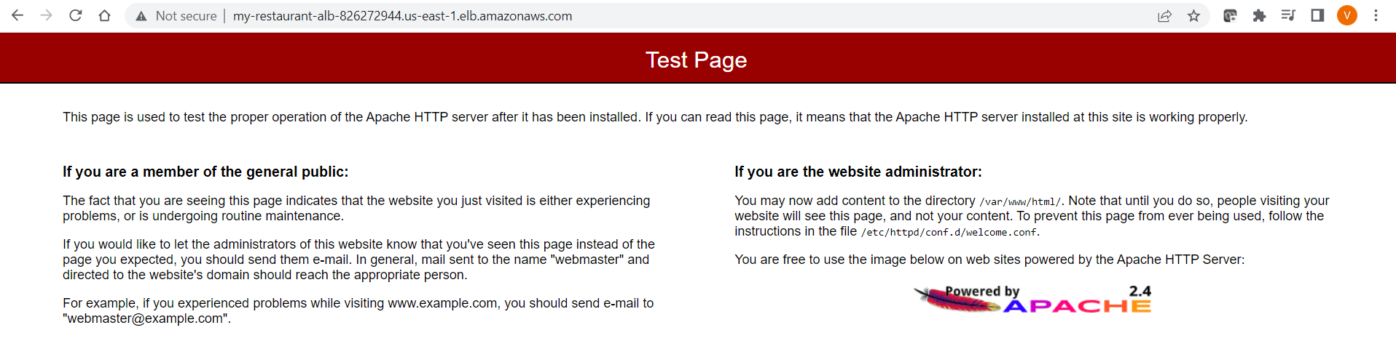

If you put in the address <http://my-restaurant-alb-826272944.us-east-1.elb.amazonaws.com/customer-recipe.html>, you will get the main page like this:

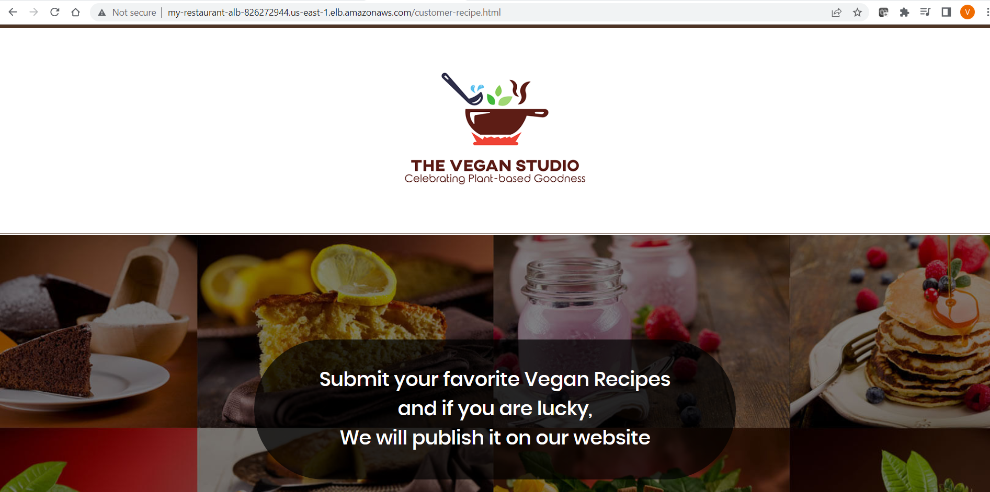

You should be able to enter the recipe details and the details should be captured and displayed as shown below:

